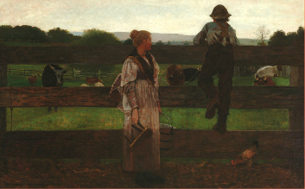
Chores
One day there was a boy named Joe who lived on a farm. He lived on the farm with his mom and dad. Every morning he had to go out and milk the cows at 5:30 in the morning. After Joe milked the cows, he would than have to get the milk ready for pick up and head off to school. Once Joe was home from school Joe would go and visit the cows and tell them what he had learned that day in school. Once he was does visiting with the cows Joe would have to go inside and work on his homework and eat dinner as well as head to bed for another busy day the next day.
Milking Time
By: Winslow Homer

