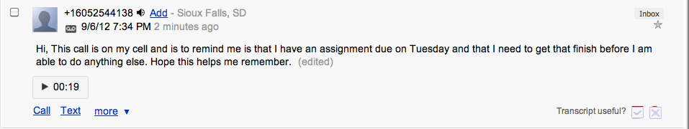

The process of setting up a Google Voice account was easy. I was able to choose my own phone number and was able to set it up to my home phone or even cell pone. I found it very easy to leave a message and than wait for it to be converted into text. I also found it nice that you could read the message rather than have to listen to it and how you are able to edit the message if something was spelled wrong or was inserted that wasn’t suppose to be there. Overall, I found Google Voice easy to use as long as you did not have a previous account with them.

